Körber releases new cloud-native PAS-X Track & Trace to strengthen serialization compliance and system efficiency with comprehensive lifecycle management
柯尔柏发布全新云原生PAS-X追踪追溯系统，以通过全面的生命周期管理加强序列化合规性和系统效率

Lüneburg, Germany, 4 March 2025. Körber has launched the latest version of its PAS-X Track & Trace solution, designed to minimize total cost of ownership (TCO) and enhance efficiency through comprehensive lifecycle management and seamless, vendor-agnostic system integration. As the industry evolves rapidly, this advanced solution meets the increasing demand for robust automation, process stability, and flexible connectivity – without restricting companies to a single technology stack.
德国吕讷堡，2025年3月4日。柯尔柏推出了其维隆PAS-X追踪追溯解决方案的最新版本。旨在通过全面的生命周期管理和无缝的、独立于供应商的系统集成，尽可能地降低总体拥有成本（TCO），并提升效率。随着行业的快速发展，这一先进解决方案满足了对强大自动化、流程稳定性和灵活连接性日益增长的需求——同时不会限制企业仅依赖单一技术栈。

Pharmaceutical and biotech companies must comply with various market-specific anti-counterfeiting requirements, such as GS1 standards, Russian crypto codes, Chinese NMPA, FDA, EMA, and more. They need to globally serialize their products and manage the associated complexities. New packaging lines and legislative changes must be incorporated flexibly. Security gaps shorten the support cycles of IT systems and present a challenge to keep the system up to date and validated with minimal effort.
制药和生物技术公司必须遵守各个市场特定的防伪要求，例如GS1标准、俄罗斯加密编码、中国国家药品监督管理局（NMPA）、美国食品药品监督管理局（FDA）、欧洲药品管理局（EMA）等。他们需要在全球范围内对产品进行序列化，并应对由产生的复杂性。新的包装线和法规变更需要灵活整合。安全漏洞会缩短IT系统的支持周期，给系统保持最新状态和以尽可能少的工作量来完成验证带来了挑战。

PAS-X Track & Trace V3 addresses these challenges, featuring advanced technology with automatic scaling, optimized deployment procedures, and centralized system operation. Its cloud-based design allows it to run on-premise, in the customer's cloud, or fully managed by Körber as Software as a Service (SaaS), fitting into any company's business strategy. Körber provides continuous support to keep the system up-to-date, along with an optimized validation approach that significantly reduces customer efforts for revalidation.
PAS-X追踪追溯V3版本为了应对这些挑战，配备了自动扩展、优化的部署流程以及集中式系统操作功能的先进技术。其基于云的设计使其能够以本地部署（on-premise）、在客户的云环境中或由柯尔柏全托管的软件即服务（SaaS）模式运行，以契合各类公司的业务战略。柯尔柏将始终提供持续的支持以确保系统保持最新状态，并采用优化的验证方法，显著减少客户重新验证时的工作量。

“PAS-X Track & Trace ensures compliance with regulatory standards while boosting operational efficiency. The latest version is a lean, functional complete and cloud-native solution designed to simplify daily operations and enable digital transformation as part of broader company strategies. Customers benefit from reduced total cost of ownership (TCO), comprehensive lifecycle management, and a future-proof software solution that aligns with their long-term IT strategy,” says René Reuter, Product Owner Software at Körber Business Area Pharma.
“PAS-X追踪追溯系统在确保符合监管标准的同时也提升了运营效率。最新版本是一个精简、功能完备且基于原生云架构的解决方案，旨在简化日常操作，赋能数字化转型，作为更广泛企业战略的一部分。客户将受益于更低的总体拥有成本（TCO）、全面的生命周期管理，以及与他们长期IT战略相契合的面向未来的软件解决方案。”柯尔柏医药科技业务领域的软件产品经理René Reuter表示。

The serialization solution serves as a vendor-agnostic site manager and harmonization layer between site and enterprise systems, seamlessly integrating packaging lines, MES and ERP systems, as well as serial number repositories from any vendor through standardized and configurable interfaces. It can be quickly implemented with reduced qualification requirements due to its configurable integration into existing business processes and fully qualified out-of-the-box standard product design.
该序列化（serialization）解决方案作为供应商独立的生产现场的管理器，以及介于生产现场与企业系统之间的协调层，通过标准化且可配置的接口，无缝集成包装线、生产执行系统（MES）、企业资源规划（ERP）系统以及相关供应商的序列号库。由于其可配置性，该系统能够快速集成到现有业务流程中，并凭借其经过全验证的开箱即用的标准化产品设计，减少了对系统确认的要求。

Picture
图片
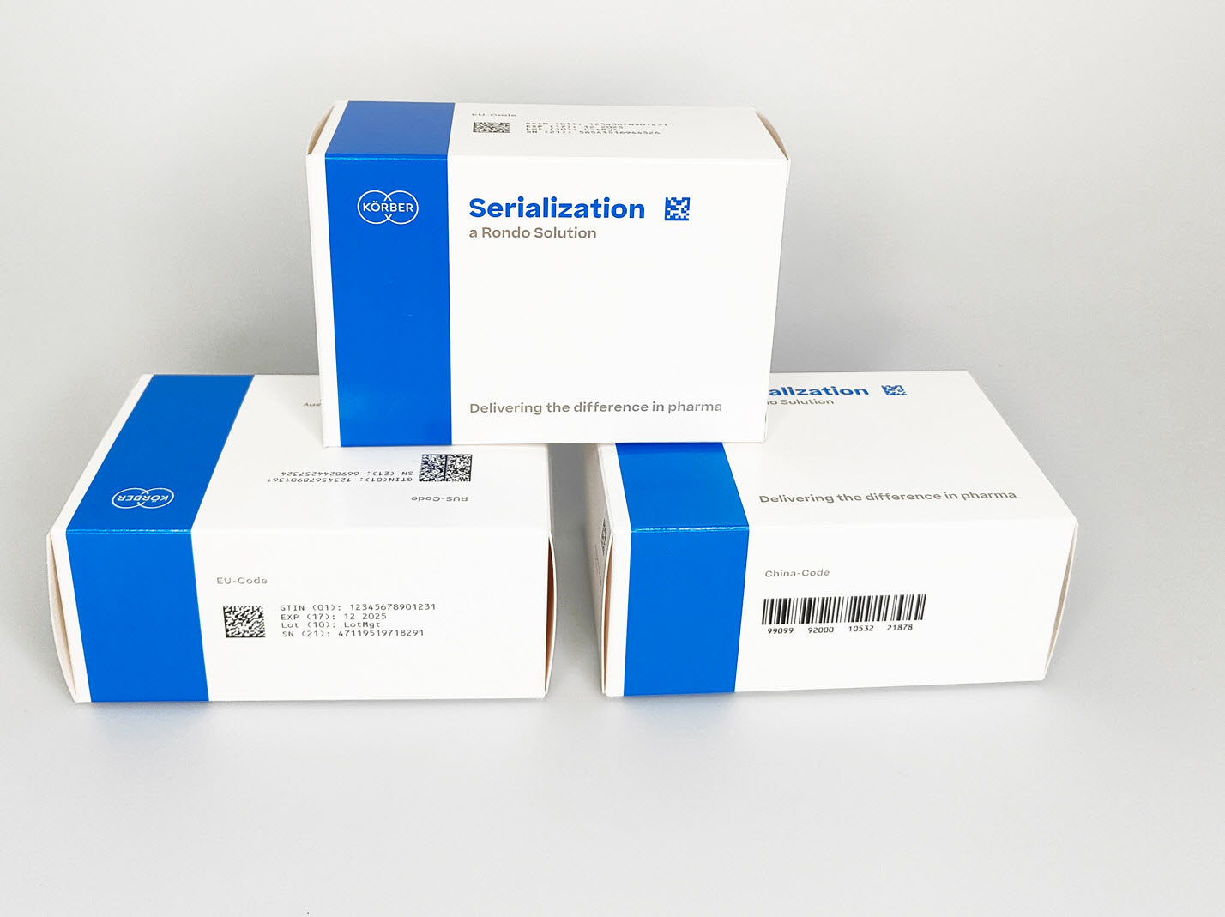

About Körber
关于柯尔柏

We are Körber – an international technology group with around 13,000 employees at over 100 locations worldwide and a common goal: We turn entrepreneurial thinking into customer success and shape the technological change. In the Business Areas Digital, Pharma, Supply Chain, and Technologies, we offer products, solutions and services that inspire. We act fast to customer needs, we execute ideas seamlessly, and with our innovations we create added value for our customers. In doing so, we are increasingly building on ecosystems that solve the challenges of today and tomorrow. Körber AG is the holding company of the Körber Group.
我们是柯尔柏——一家国际技术集团，在世界各地有100多个分支机构，拥有约 13,000 名员工，所有人都有一个共同的目标：我们将企业家精神转化为客户成功，并塑造技术变革。在数字化、医药科技、供应链和工程技术等业务领域，我们提供激发灵感的产品、解决方案和服务。我们快速响应客户需求并无缝执行创意，通过创新为客户创造附加值。我们不断完善生态系统，以解决当今和未来的挑战。柯尔柏股份公司是柯尔柏集团的控股公司。

At the Körber Business Area Pharma we are delivering the difference along the pharma value chain with our unique portfolio of integrated solutions. With our software solutions we help drug manufacturers to digitize their pharmaceutical, biotech and cell & gene therapy production. The Werum PAS-X MES Suite is recognized as the world’s leading Manufacturing Execution System for pharma, biotech and cell & gene. Our Werum PAS-X Savvy Suite accelerates product commercialization with data analytics and AI solutions and uncovers hidden business value.

www.koerber-pharma.com

在柯尔柏医药科技业务领域，我们通过独特的集成解决方案组合，在制药价值链上实现差异化。我们的软件解决方案帮助制药企业实现制药、生物技术、细胞和基因治疗生产流程的数字化。维隆PAS-X MES套件是公认的一款适用于制药、生物技术和细胞与基因领域的生产执行系统。我们的维隆PAS-X Savvy智能套件通过数据分析和人工智能解决方案加速产品商业化，并发现隐藏的商业价值。

www.koerber-pharma.com

Contact
Dirk Ebbecke
Körber Business Area Pharma
Head of Product Marketing
T: +49 4131 8900-0
E-mail: dirk.ebbecke@koerber.com

Dirk Ebbecke
柯尔柏医药科技业务领域
产品市场总监
+49 4131 89000
dirk.ebbecke@koerber.com

